Approval of the Minutes - June 5, 2019 WWC Board Meeting
Suggested Remarks
- We will take a Vote to Approve from Members present who were at the June meeting. New Members should not vote.
- Former Members received the minutes for review and comment.
- We received approval without changes from Mary Jo Baas and Karen Katz. Also from Cindy Block who is not able to be here today.
- 1 correction was made, Jessie Nicholson was not present.
ASK: Any additional changes?
ASK: Is there a MOTION TO APPROVE the minutes of June 5, 2019, engaging only Members who were present at that meeting.

>> I am not sure where this fits into the agenda – it could go at the beginning with the welcome or at the end under “Other Board Business”.
RECOGNIZE OUTGOING BOARD MEMBERS
For the record, I want to recognize and thank the outgoing members of the Women’s Council – Outgoing Chair Mary Jo Baas, Karen Katz and Katie Mnuk - for their service and dedication and the impact they had on the Women’s Council Board and serving the women of Wisconsin.
Direct Christine to provide them with a letter thanking them for such and the Council’s customary Recognition of Service certificate for outgoing members.

New Governor’s Appointees | Name  Issues raised | Home location  occup./background
 | Denise  Gaumer Hutchinson  - School vouchers  - How does the environment impact quality of life  - Women’s chamber of commerce  - GET SOMETHING DONE! | Green Bay area  Campaign organizing  Community and Event organizing  Small business
 | Chantia Lewis  - Infant Mortality  - Single Mothers & Poverty  - Homelessness  - Childcare  - Veterans | Milwaukee  Alderwoman
 | Rosalyn McFarland  - Infant Mortality  - Racial/Ethnic Health Disparities | Brown Deer  Nurse Practitioner  Family Practice  Small Biz Owner
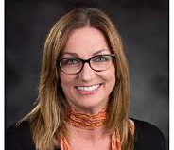 | Nerissa Nelson  General, nothing specific raised How policy/budget work | Stevens Point  UW Stevens Point Librarian
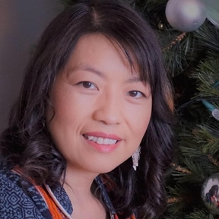 | Ze (prounced Zeee) Yang  Hmong community  Open on issues not much in specific asks  Has 6 children including an infant | Madison  Bi-lingual Educator Verona School Dist.  Working on PhD  FOG who asked her personally to serve on Council
Continuing Public Members
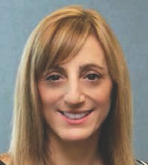 | Lisa Armaganian  reappointed Governor  - Single Mother supports  - Passion for supporting kids that age out of foster care  - Preventive health care |  | Brookfield  Physician  Non-invasive cardiac surgeon at Ascension Health Care.  Ascension is open to funding requests for programs or projects.
 | Cindy Block  Senate President Appointment  - Hasn’t been available to talk on issues. |  | Cottage Grove
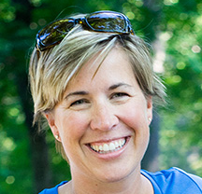 | Kim Nickel  Assembly Speaker Appointment  - Hasn’t been available to talk on issues. |  | Middleton  Graphic Designer  Small biz owner
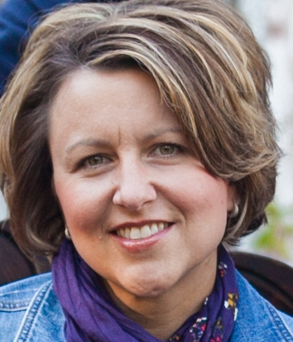 | Carrie Richard  Assembly Speaker Appointment  - Data collection & reporting  - Status of Women report |  | Mazomanie
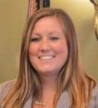 | Shelby Schmudlach  Senate President Appointment  - Hasn’t been available to speak on issues. |  | Cottage Grove

